Movies (for narrative)

Memento

good fellas

mystic river

Games (for game design and puzzle mechanics)

La. noire

Vanishing of ethen carter

Return of the Obra Dinn

Resources

Videos:

-- Puzzles in games

[What Makes a Good Detective Game?](https://www.youtube.com/watch?v=gwV_mA2cv_0)

[How The Forgotten City Works](https://youtu.be/8W_WHbZDBKU)

[The Power of Invisible Choices](https://youtu.be/6HZuSzlN2eI)

[What Makes a Good Puzzle?](https://youtu.be/zsjC6fa_YBg)

[Weaving 13 Prototypes into 1 Game: Lessons from Edith Finch](https://youtu.be/0xVYVP0hxME)

[The System Behind Hades' Astounding Dialogue](https://www.youtube.com/watch?v=bwdYL0KFA_U&t=0s)

[Interactive Story Without Challenge Mechanics: The Design of Firewatch](https://www.youtube.com/watch?v=RVFyRV43Ei8&t=0s)

-- Game design and narrative design (research premise)

[Sparking Curiosity-Driven Exploration Through Narrative in 'Outer Wilds'](https://youtu.be/QaGu9tGCNbI)

[DiGRA '19 - Proceedings of the 2019 DiGRA International Conference: Game, Play and the Emerging Ludo-Mix](http://www.digra.org/wp-content/uploads/digital-library/DiGRA_2019_paper_410.pdf)

A narrative puzzle is both a narrative event (or a part of a narrative event) and a mental challenge with at least one correct solution that requires the player to discover and execute a particular series of actions

Using a slightly different approach to the in-game objects, game author and blogger Jasper McChesney (2017) proposed a two-tier taxonomy of adventure puzzles based on the characteristics of objects involved in a puzzle. He identified four types of objects in the game world inventory and environment. The first type is inventory items, which are movable, reusable, and combinable with one another to form new objects. The second type is environment items, which are stationary, more static, and interacting with inventory items at a fixed in-game location. The third type is items that are not yet included in the inventory and waiting to be picked up often as a reward instead of being a puzzle element. The four type is information, journals, notes gathered to interact with the NPCs, which do not engage with physical or mechanical puzzles. Based on one or a combination of the above types of objects, McChesney derived a series of puzzle types, such as “mysterious device,” “fetch,” “key in lock,” “gather clues,” “hunt the pixel,” and so on.

~ Art Style

[A Living Painting: The Rendering and Art of 11-11 Memories Retold](https://youtu.be/Md8l_GK9Sfg)

Articles/ Books:

~ Game design and narrative design (research premise)

[Exploring the Role of Narrative Puzzles in Game Storytelling](http://www.digra.org/wp-content/uploads/digital-library/DiGRA_2019_paper_410.pdf)

Portfolio Example

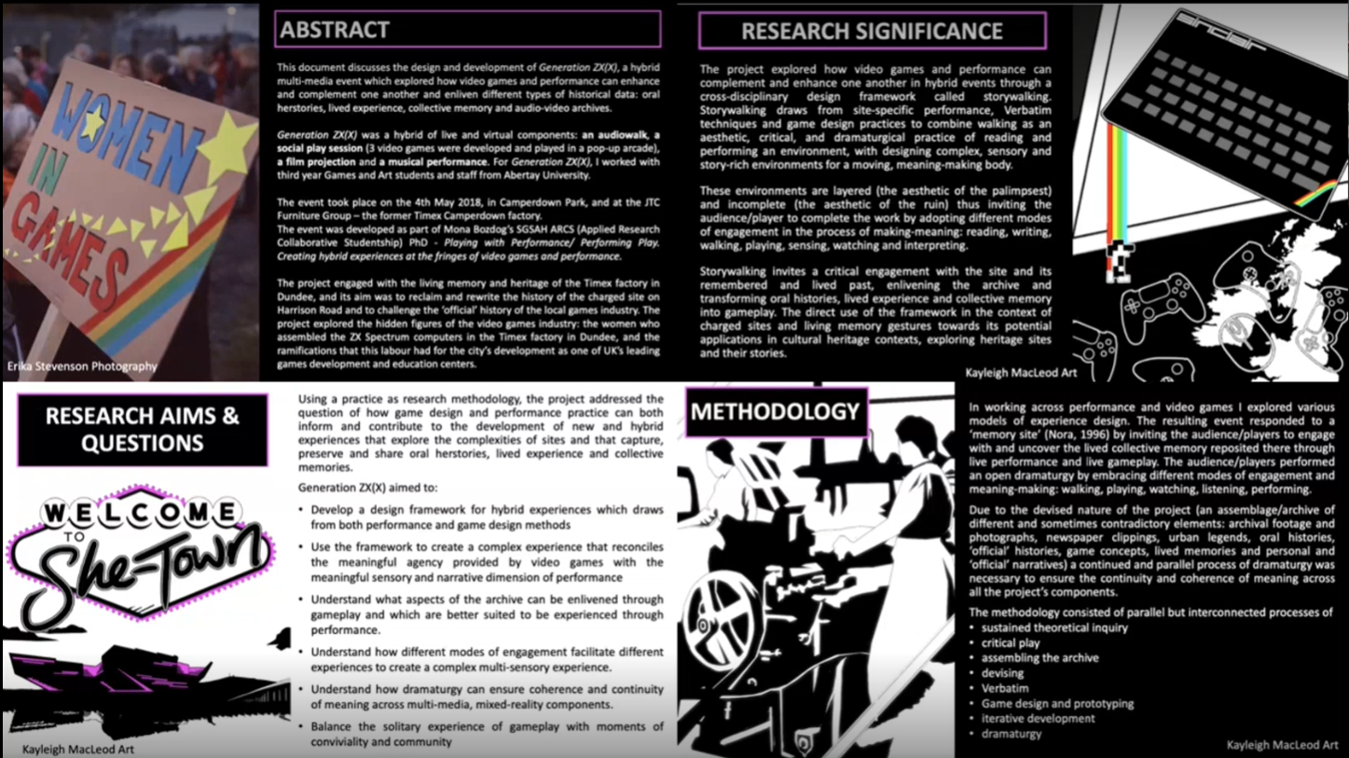

If for some reason your particle effects don't look right with an orthographic camera, you could try rendering them with a perspective camera. Just assign the particle effect GameObjects to a "Particles" layer and set the Culling Mask on the perspective camera accordingly.